**DAILY ONLINE ACTIVITIES SUMMARY**

|  |  |  |  |  |  |  |  |
| --- | --- | --- | --- | --- | --- | --- | --- |
| **Date:** | 27/05/2020 | | | | **Name:** | AMBIKA V | |
| **Sem & Sec** | 4th SEM SECTION 'A' | | | | **USN:** | 4AL18CS005 | |
| **Online Test Summary** | | | | | | | |
| **Subject** | | Object Oriented Concepts(18CS45) | | | | | |
| **Max. Marks** | | 30 | | **Score** | | 14 | |
| **Certification Course Summary** | | | | | | | |
| **Course** | Introduction to Cyber Security | | | | | | |
| **Certificate Provider** | | | GreatLearning Academy | **Duration** | | | 7 Hours |
| **Coding Challenges** | | | | | | | |
| **Problem Statement:** **1.** Given an array A of size N where the array elements contain values from 1 to N with duplicates, the task is to find total number of subarrays which start and end with the same element. | | | | | | | |
| **Status:** Completed | | | | | | | |
| **Uploaded the report in Github** | | | | YES | | | |
| **If yes Repository name** | | | | https://github.com/ambika0202/lockdown-coding- | | | |
| **Uploaded the report in slack** | | | | YES | | | |

**Online Test Details:**

The online test was from module 5 which was about the Event Handling and Swings. There were 30 questions and the duration was 30 minutes. The questions were optimal and were easy. The score that I got in the test is 14/30.

**Snapshot:**

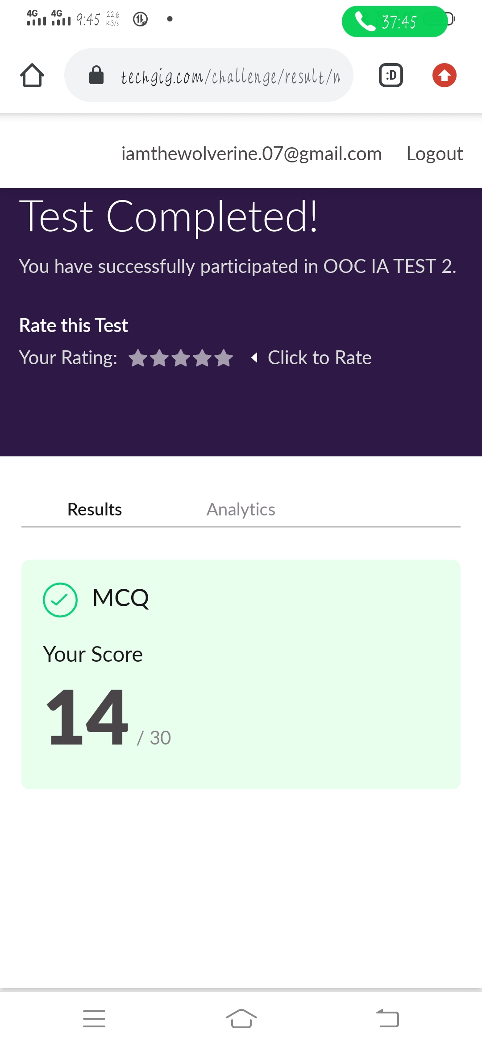

**Certification Course Details:**

**Name of the course**: Introduction to Cyber Security

**Certificate Provider**: Great Learning Academy

Today I went through the three sessions of the course that explained about threats and vulnerabilities and What is cybersecurity

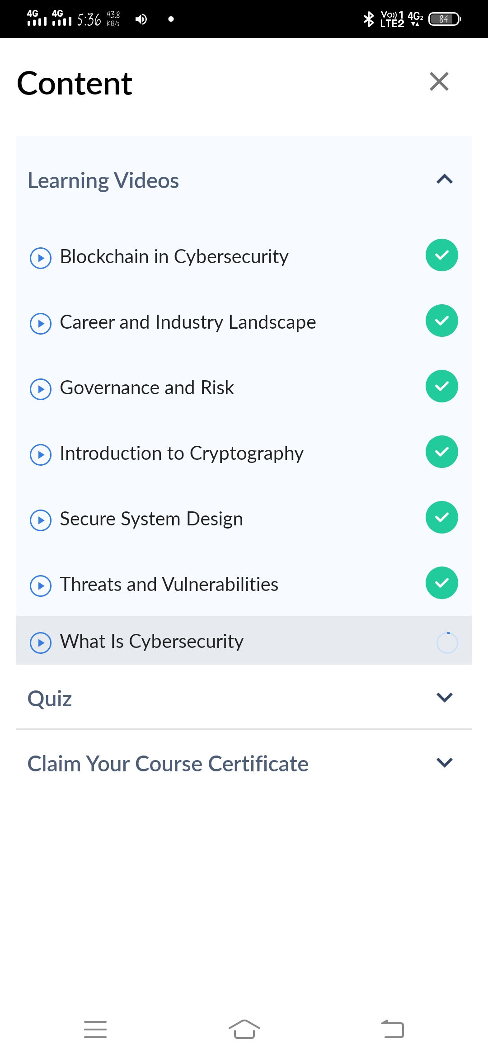**Snapshot:**

**1Threats and Vulnerabilities**

A threat is what we're trying to protect against. Vulnerability – Weaknesses or gaps in a security program that can be exploited by threats to gain unauthorized access to an asset. ... Risk – The potential for loss, damage or destruction of an asset as a result of a threat 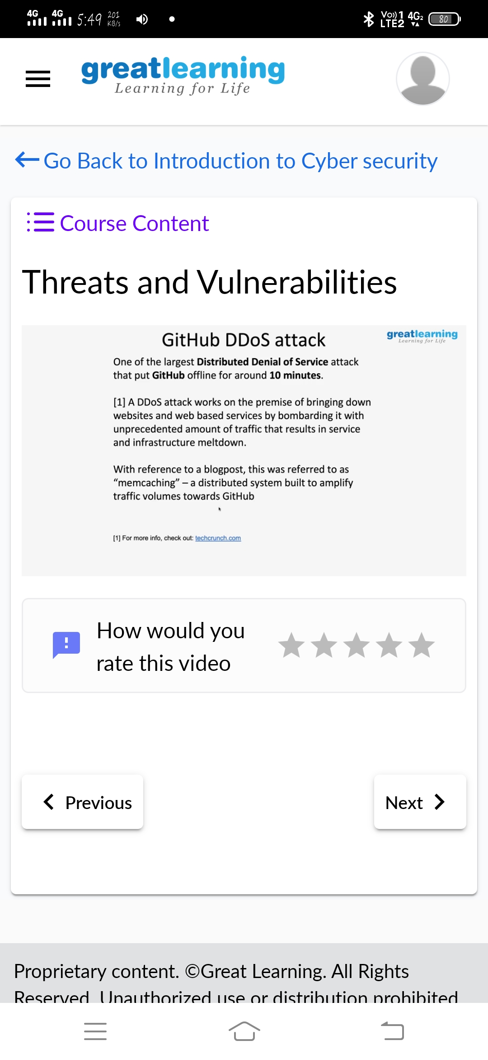exploiting a vulnerability.

**2.What is cybersecurity**

Cyber security is the practice of defending computers, servers, mobile devices, electronic systems, networks, and data from malicious attacks. It's also known as information technology security or electronic information security. A compromised application could provide access to the data its designed to protect.

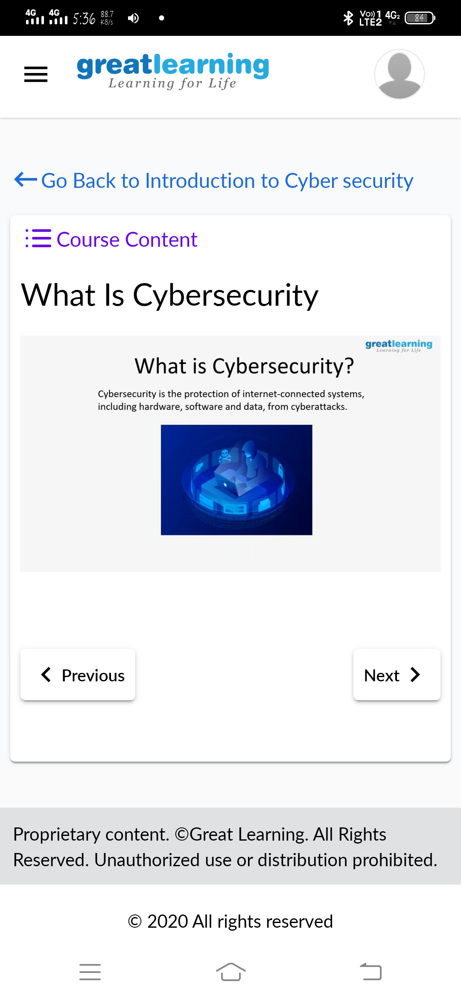

**Online Coding Details:**

**Problem statement 1:** Given an array A of size N where the array elements contain values from 1 to N with duplicates, the task is to find total number of subarrays which start and end with the same element.

Sn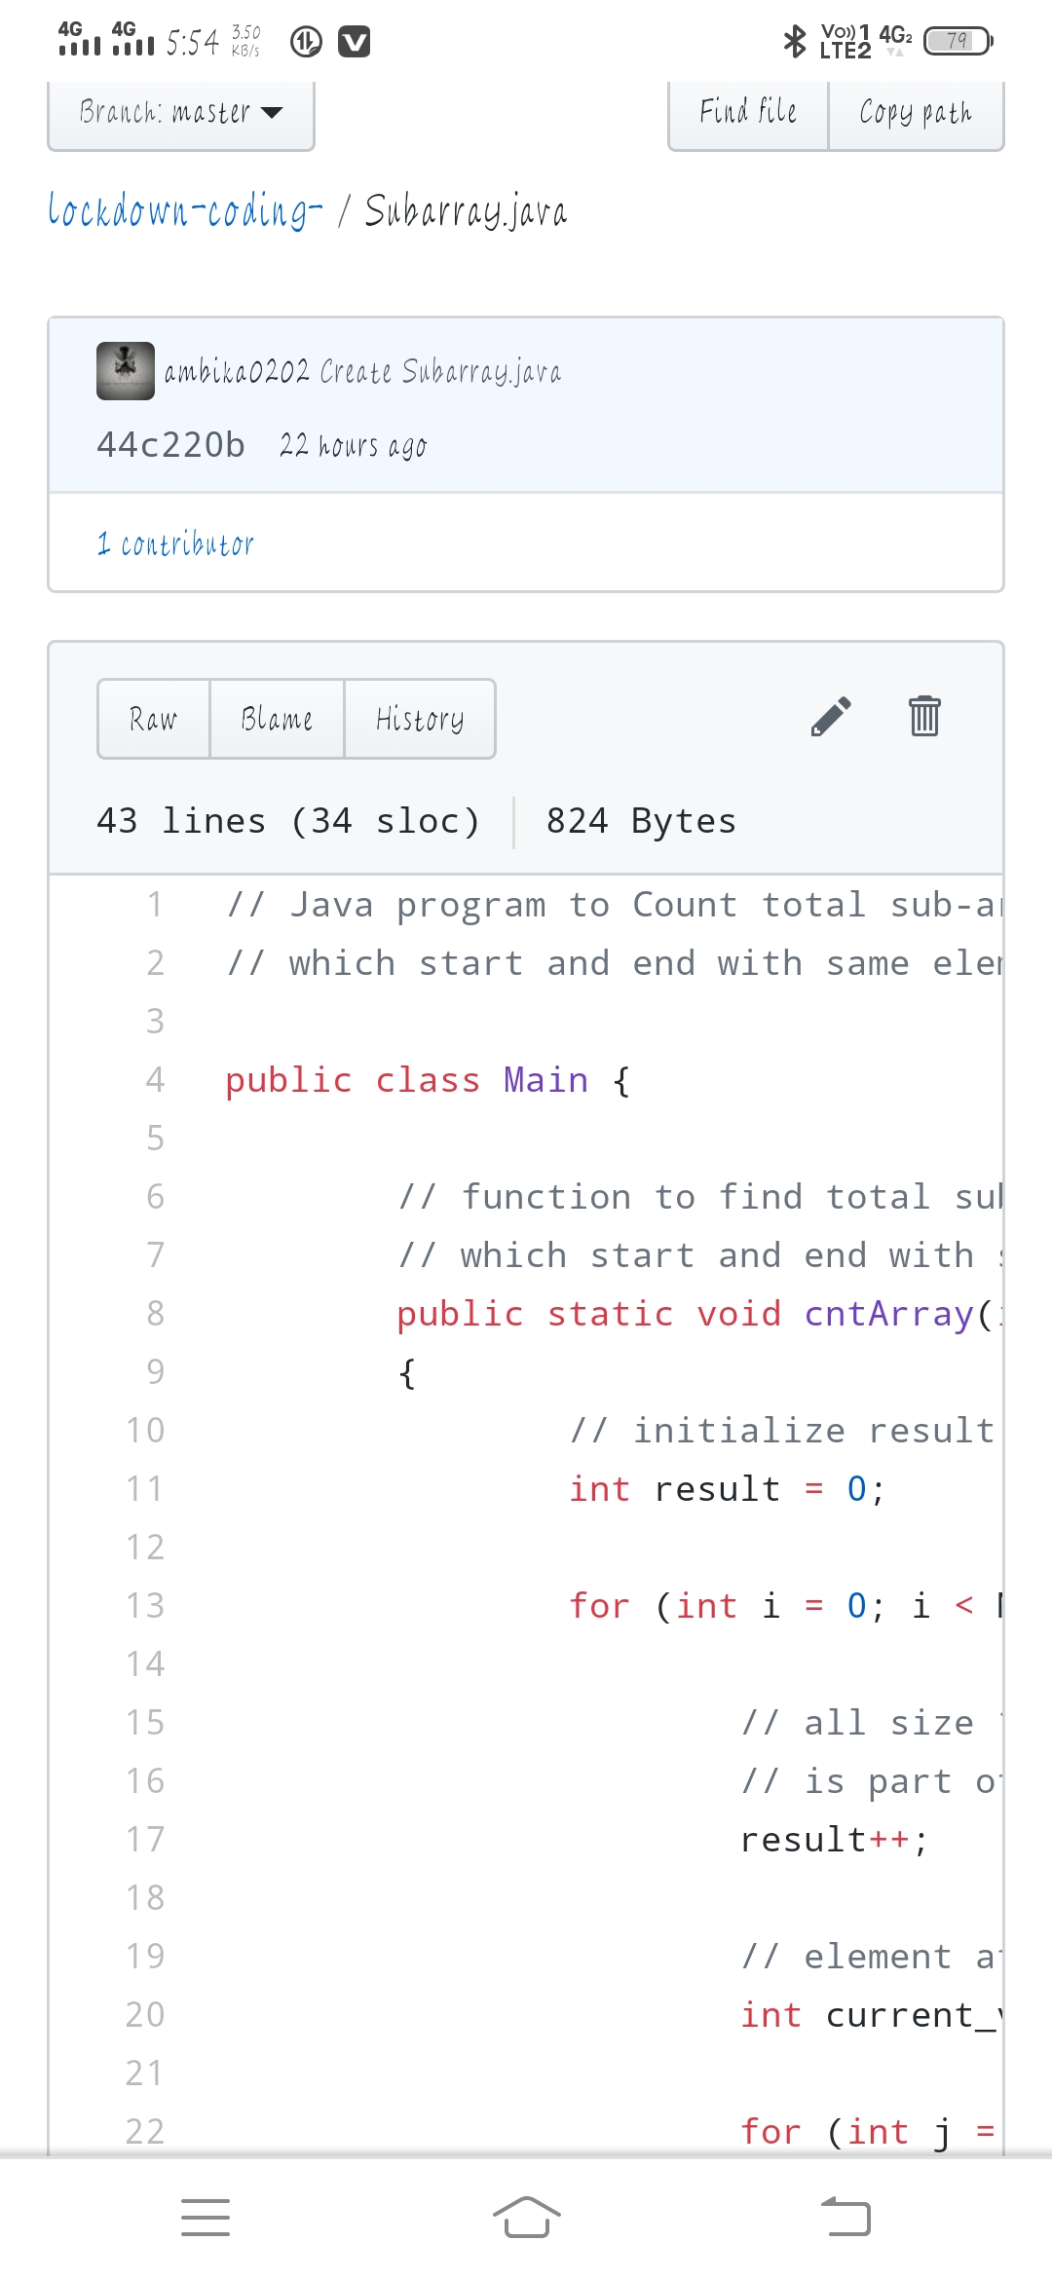apshot: